# Solving medium DP Problems

## Recap

For DP, we need:-

1. Recursive relation (with base case)

2. Overlapping subproblems

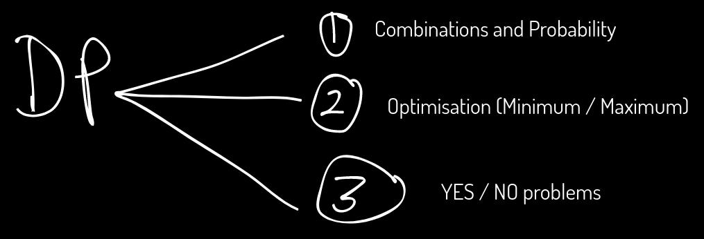

## 

## Basics of Combinatorics

### Product Rule:

If a job A can be done in **m ways** and after it is done, another job B can be done in **n ways**, then total number of ways to do both A **AND** B is m*n ways.

**(Independent jobs)**

**Eg.** You need to form a team for ICPC of 1 mathematician, 1 programmer and 1 gamer. There are a total of 10 mathematicians, 15 programmers and 5 gamers in your college. In how many ways, can you form a team ?

- 10 ways to select a mathematician

- 15 ways to select a programmer

- 5 ways to select a gamer

Total ways = 10 x 15 x 5

### Sum Rule

If a job A can be done in m ways and another job B can be done in n ways, then total number of ways to do both either A **OR** B is m+n ways.

**Eg.** You need to form a team for ICPC of 1 mathematician or 1 programmer or 1 gamer. There are a total of 10 mathematicians, 15 programmers and 5 gamers in your college. In how many ways, can you form a team ?

- 10 ways to select a mathematician

- 15 ways to select a programmer

- 5 ways to select a gamer

Total ways = 10 + 15 + 5 = 30

### Problem 1: Array Description

Link: <https://cses.fi/problemset/task/1746/>

Link to my code: <https://cses.fi/paste/24fd50ca8e4cb856203207/>

### Problem 2: Coin Combinations I

Link: <https://cses.fi/problemset/task/1635>

Link to my code: <https://cses.fi/paste/33c8a1398ac7c753203fba/>

### Problem 3: Coin Combinations II

Link: <https://cses.fi/problemset/task/1636>

Link to my code: <https://cses.fi/paste/4a0ca5f0bd1fe8dc204113/>

### Problem 4: Exponential Subsets (Hackerearth)

Link: <https://www.hackerearth.com/practice/algorithms/dynamic-programming/2-dimensional/practice-problems/algorithm/exponential-subset-f78d066f/>

Link to my code: <https://www.hackerearth.com/submission/key/1899bbc5d4f744a49e3d6970000c34d6/>

**HomeWork**

### 

### Problem 5: Two Sets II

Link: <https://cses.fi/problemset/task/1093>

Link to my code: <https://cses.fi/paste/9b9f6fc873b99b19140b72/>